**American University/NASA SPACE GRANT CONSORTIUM/District of Columbia Public Schools**

DATA SCIENCE / R Programing Professional Development

Summer 2021

Lab **Using R for Data Visualization**

1)

a) Copy and paste the data table below into a new and blank R Script Pane.

**tribble(~Planet, ~Mass, ~Diameter, ~Density, ~Gravity, ~DayLength, ~MeanTemp,~DistfSun,**

**"Mercury",.330, 4879, 5427, 3.7, 4222.6, 167, 57.9,**

**"Venus", 4.87, 12104, 5243, 8.9, 2802, 464, 108.2,**

**"Earth", 5.97, 12756, 5514, 9.8, 24, 15, 149.6,**

**"Mars", .642, 6792, 3933, 3.7, 24.7,-65, 227.9,**

**"Jupiter", 1898, 142984, 1326, 23.1, 9.9, -110, 778.6,**

**"Saturn", 568, 120536, 687, 9.0, 10.7, -140, 1433.5,**

**"Uranus", 86.8, 51118, 1271, 8.7, 17.2, -195, 2872.5,**

**"Neptune", 102, 49528, 1638, 11.0, 16.1, -200, 4495.1,**

**"Pluto", .0146, 2370, 2095, .7, 153.3, -225, 5906.4) -> Planets**

**Planets**

b) Highlight and run the data table. You should see the table established in the console of the R Studio IDE.

2) Show and use R code to produce the following statistical summaries for the variable **Mass** of the Planets Data Table.

a) Mean b) Maximum c) Standard Deviation

3) Using appropriate R code, Apply the summary function to the Mass variable of the Planets Data Table; What output is generated ?

4) Show and use R code to produce a boxplot for the variable **MeanTemp** of the Planets Data Table

5) Show and use R code to produce a frequency polygon for the **Mass** variable of the Planets Data Table.

6) Show and use R code that will produce the bar graph given below.

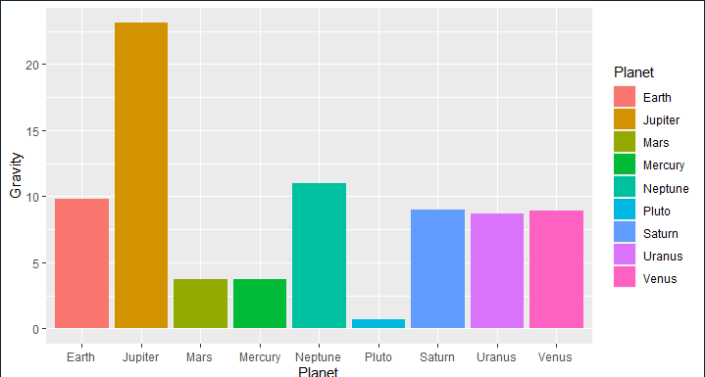

7) Show and use R code to produce a scatter plot that shows a relationship between the variables **DistfSun** and **MeanTemp. DistfSun** is **x** and **MeanTemp** is **y.**

8) Type and run the following commands in your R script screen. If you have not done so already.

Install.packages (“plotrix”)

library(plotrix)

Using the planets Jupiter, Saturn, Uranus, Neptune, and Pluto, and their associated Mass measurements, Use and show R code that will produce the 3D Pie Chart given below.

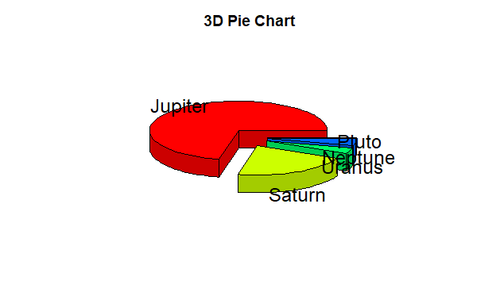

For problem 9, generate correct code in the R script pane , run and test your code to make certain that it works, then copy and past to R markdown; creating an Rmarkdown file and a Word file, saving both files on the desktop of your computer.

9)

a) In the R script pane, type in and run the following code

library(tidyverse)

diamonds

In the console, the data table diamonds will appear.

b) Use the code nrow(diamonds) to determine how many rows the diamonds data table has.

c) Use the code ncol(diamonds) to determine how many rows the diamonds data table has.

d) Use and show R code that will produce a histogram for the variable **carat** of the diamonds data table. Add code that will full color your histogram red.

e) Use and show R code that will produce the side by side boxplots that are shown below.

